Group 3 Team Members

Martin Chamambo

Takunda Muchemwa

Gift chigayo

Netsai

Alex

1. **Create a database namely retail_db in SQL Server [2 MARKS]**

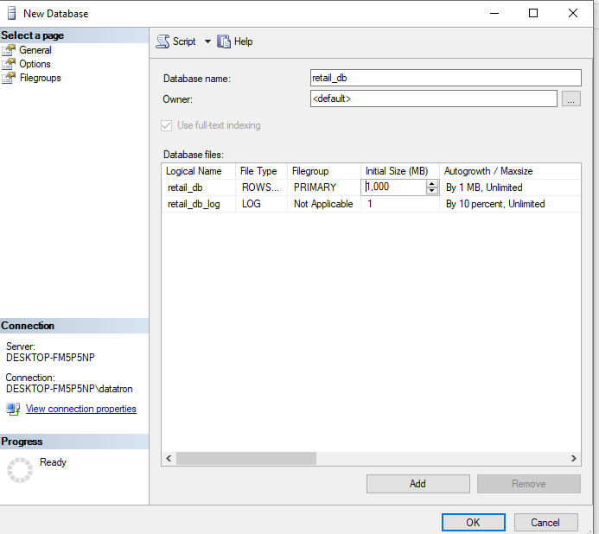

1. **Create the required tables and show the queries that you have used [12 MARKS] - We have also attached the SQL file for this question**

IF EXISTS (SELECT * FROM sysobjects WHERE id = object_id(N'[dbo].[categories]')

AND OBJECTPROPERTY(id, N'IsUserTable') = 1)

DROP TABLE [dbo].[categories];

CREATE TABLE categories (

[category_id] int NOT NULL IDENTITY,

[category_department_id] int NOT NULL,

[category_name] varchar(45) NOT NULL,

PRIMARY KEY ([category_id])

) ;

IF EXISTS (SELECT * FROM sysobjects WHERE id = object_id(N'[dbo].[customers]')

AND OBJECTPROPERTY(id, N'IsUserTable') = 1)

DROP TABLE [dbo].[customers];

CREATE TABLE customers (

[customer_id] int NOT NULL IDENTITY,

[customer_fname] varchar(45) NOT NULL,

[customer_lname] varchar(45) NOT NULL,

[customer_email] varchar(45) NOT NULL,

[customer_password] varchar(45) NOT NULL,

[customer_street] varchar(255) NOT NULL,

[customer_city] varchar(45) NOT NULL,

[customer_state] varchar(45) NOT NULL,

[customer_zipcode] varchar(45) NOT NULL,

PRIMARY KEY ([customer_id])

) ;

IF EXISTS (SELECT * FROM sysobjects WHERE id = object_id(N'[dbo].[departments]')

AND OBJECTPROPERTY(id, N'IsUserTable') = 1)

DROP TABLE [dbo].[departments];

CREATE TABLE departments (

[department_id] int NOT NULL IDENTITY,

[department_name] varchar(45) NOT NULL,

PRIMARY KEY ([department_id])

) ;

IF EXISTS (SELECT * FROM sysobjects WHERE id = object_id(N'[dbo].[order_items]')

AND OBJECTPROPERTY(id, N'IsUserTable') = 1)

DROP TABLE [dbo].[order_items];

CREATE TABLE order_items (

[order_item_id] int NOT NULL IDENTITY,

[order_item_order_id] int NOT NULL,

[order_item_product_id] int NOT NULL,

[order_item_quantity] smallint NOT NULL,

[order_item_subtotal] float NOT NULL,

[order_item_product_price] float NOT NULL,

PRIMARY KEY ([order_item_id])

) ;

IF EXISTS (SELECT * FROM sysobjects WHERE id = object_id(N'[dbo].[orders]')

AND OBJECTPROPERTY(id, N'IsUserTable') = 1)

DROP TABLE [dbo].[orders];

CREATE TABLE orders (

[order_id] int NOT NULL IDENTITY,

[order_date] datetime2(0) NOT NULL,

[order_customer_id] int NOT NULL,

[order_status] varchar(45) NOT NULL,

PRIMARY KEY ([order_id])

) ;

IF EXISTS (SELECT * FROM sysobjects WHERE id = object_id(N'[dbo].[products]')

AND OBJECTPROPERTY(id, N'IsUserTable') = 1)

DROP TABLE [dbo].[products];

CREATE TABLE products (

[product_id] int NOT NULL IDENTITY,

[product_category_id] int NOT NULL,

[product_name] varchar(45) NOT NULL,

[product_description] varchar(255) NOT NULL,

[product_price] float NOT NULL,

[product_image] varchar(255) NOT NULL,

PRIMARY KEY ([product_id])

) ;

1. **Load the data into the tables you just created [50 MARKS] - We used python to insert the data into the retail_db database and have attached the python file named LoadDataIntoTables_Group3.py**
2. **Write queries to show the total number of records in each table and take screenshots together with the results. [6 MARKS]**

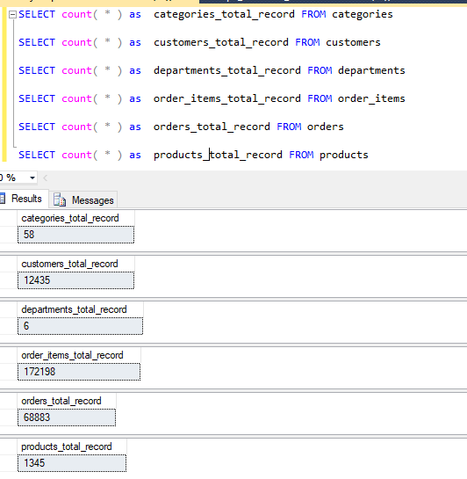

1. **Create another database called MSCDA_DW which will be your data warehouse**

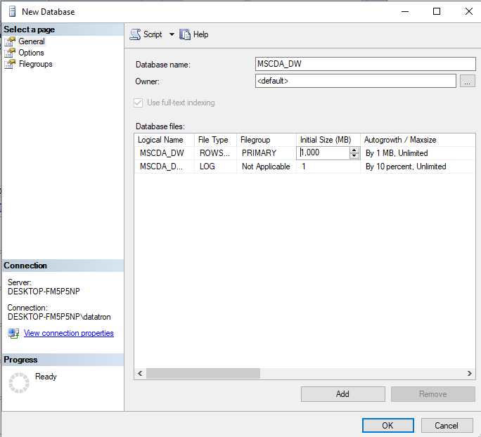

1. **During your logical data modelling phase, model a star schema which will be part of your data warehouse showing the source tables and suggested names for your facts and dimensions [5 MARKS]**
2. **Zxxz**
3. **Ssda**
4. **Sdsd**
5. **sdfs**